

REPUBLIC OF SOUTH SUDAN

Ministry of Agriculture and Food Security

Office of the Undersecretary of Cooperative, Rural Development and Administration

Ref: RSS/MAFS/USO/J/

Date: 8th September 2021

Director

GAFSP Call for proposals

Coordination Unit

[gafsp-info@gafsfund.org](mailto:gafsp-info@gafsfund.org)

Subject: Submission of FINAL GAFSP proposal - South Sudan

Dear Sir,

I would be very grateful if you could put the above mentioned subject under due consideration. I would also like to apologise on behalf of the administration of MAFS that we had access to the document late yesterday (07.09.2021) that is why we are trying to forward it to you within the shortest possible time.

The proposal is entitled as RURAL ENTERPRISE FOR AGRICULTURE DEVELOPMENT Project i.e. (READ Project).

Dear Director, this project proposal is designated to the appalling development situation in most rural areas of South Sudan. The implementation of this project can lead to improvement of livelihood of rural communities in the selected counties across the main regions of the country.

I am therefore, appealing to the **GAFSP BOARD of Directors** to consider READ project for South Sudan for approval. A number of recommendation letters from different institutions in support of this READ project are attached for justification.

I stop here looking forward for positive cooperation.

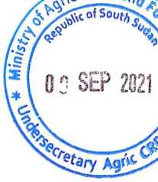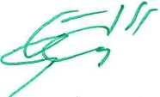Undersecretary for Administration, Coop. & Rural Develop.  
MAFS/RSS-Juba

**Prof. Mathew Gordon Udo**

CC: Hon. Minister

CC: Hon. Deputy Minister

CC: IFAD Country Director

CC: ILO Country Director

CC: MD Cooperative Bank of South Sudan

CC: File